1 Find the four errors in this algorithm written in pseudocode.

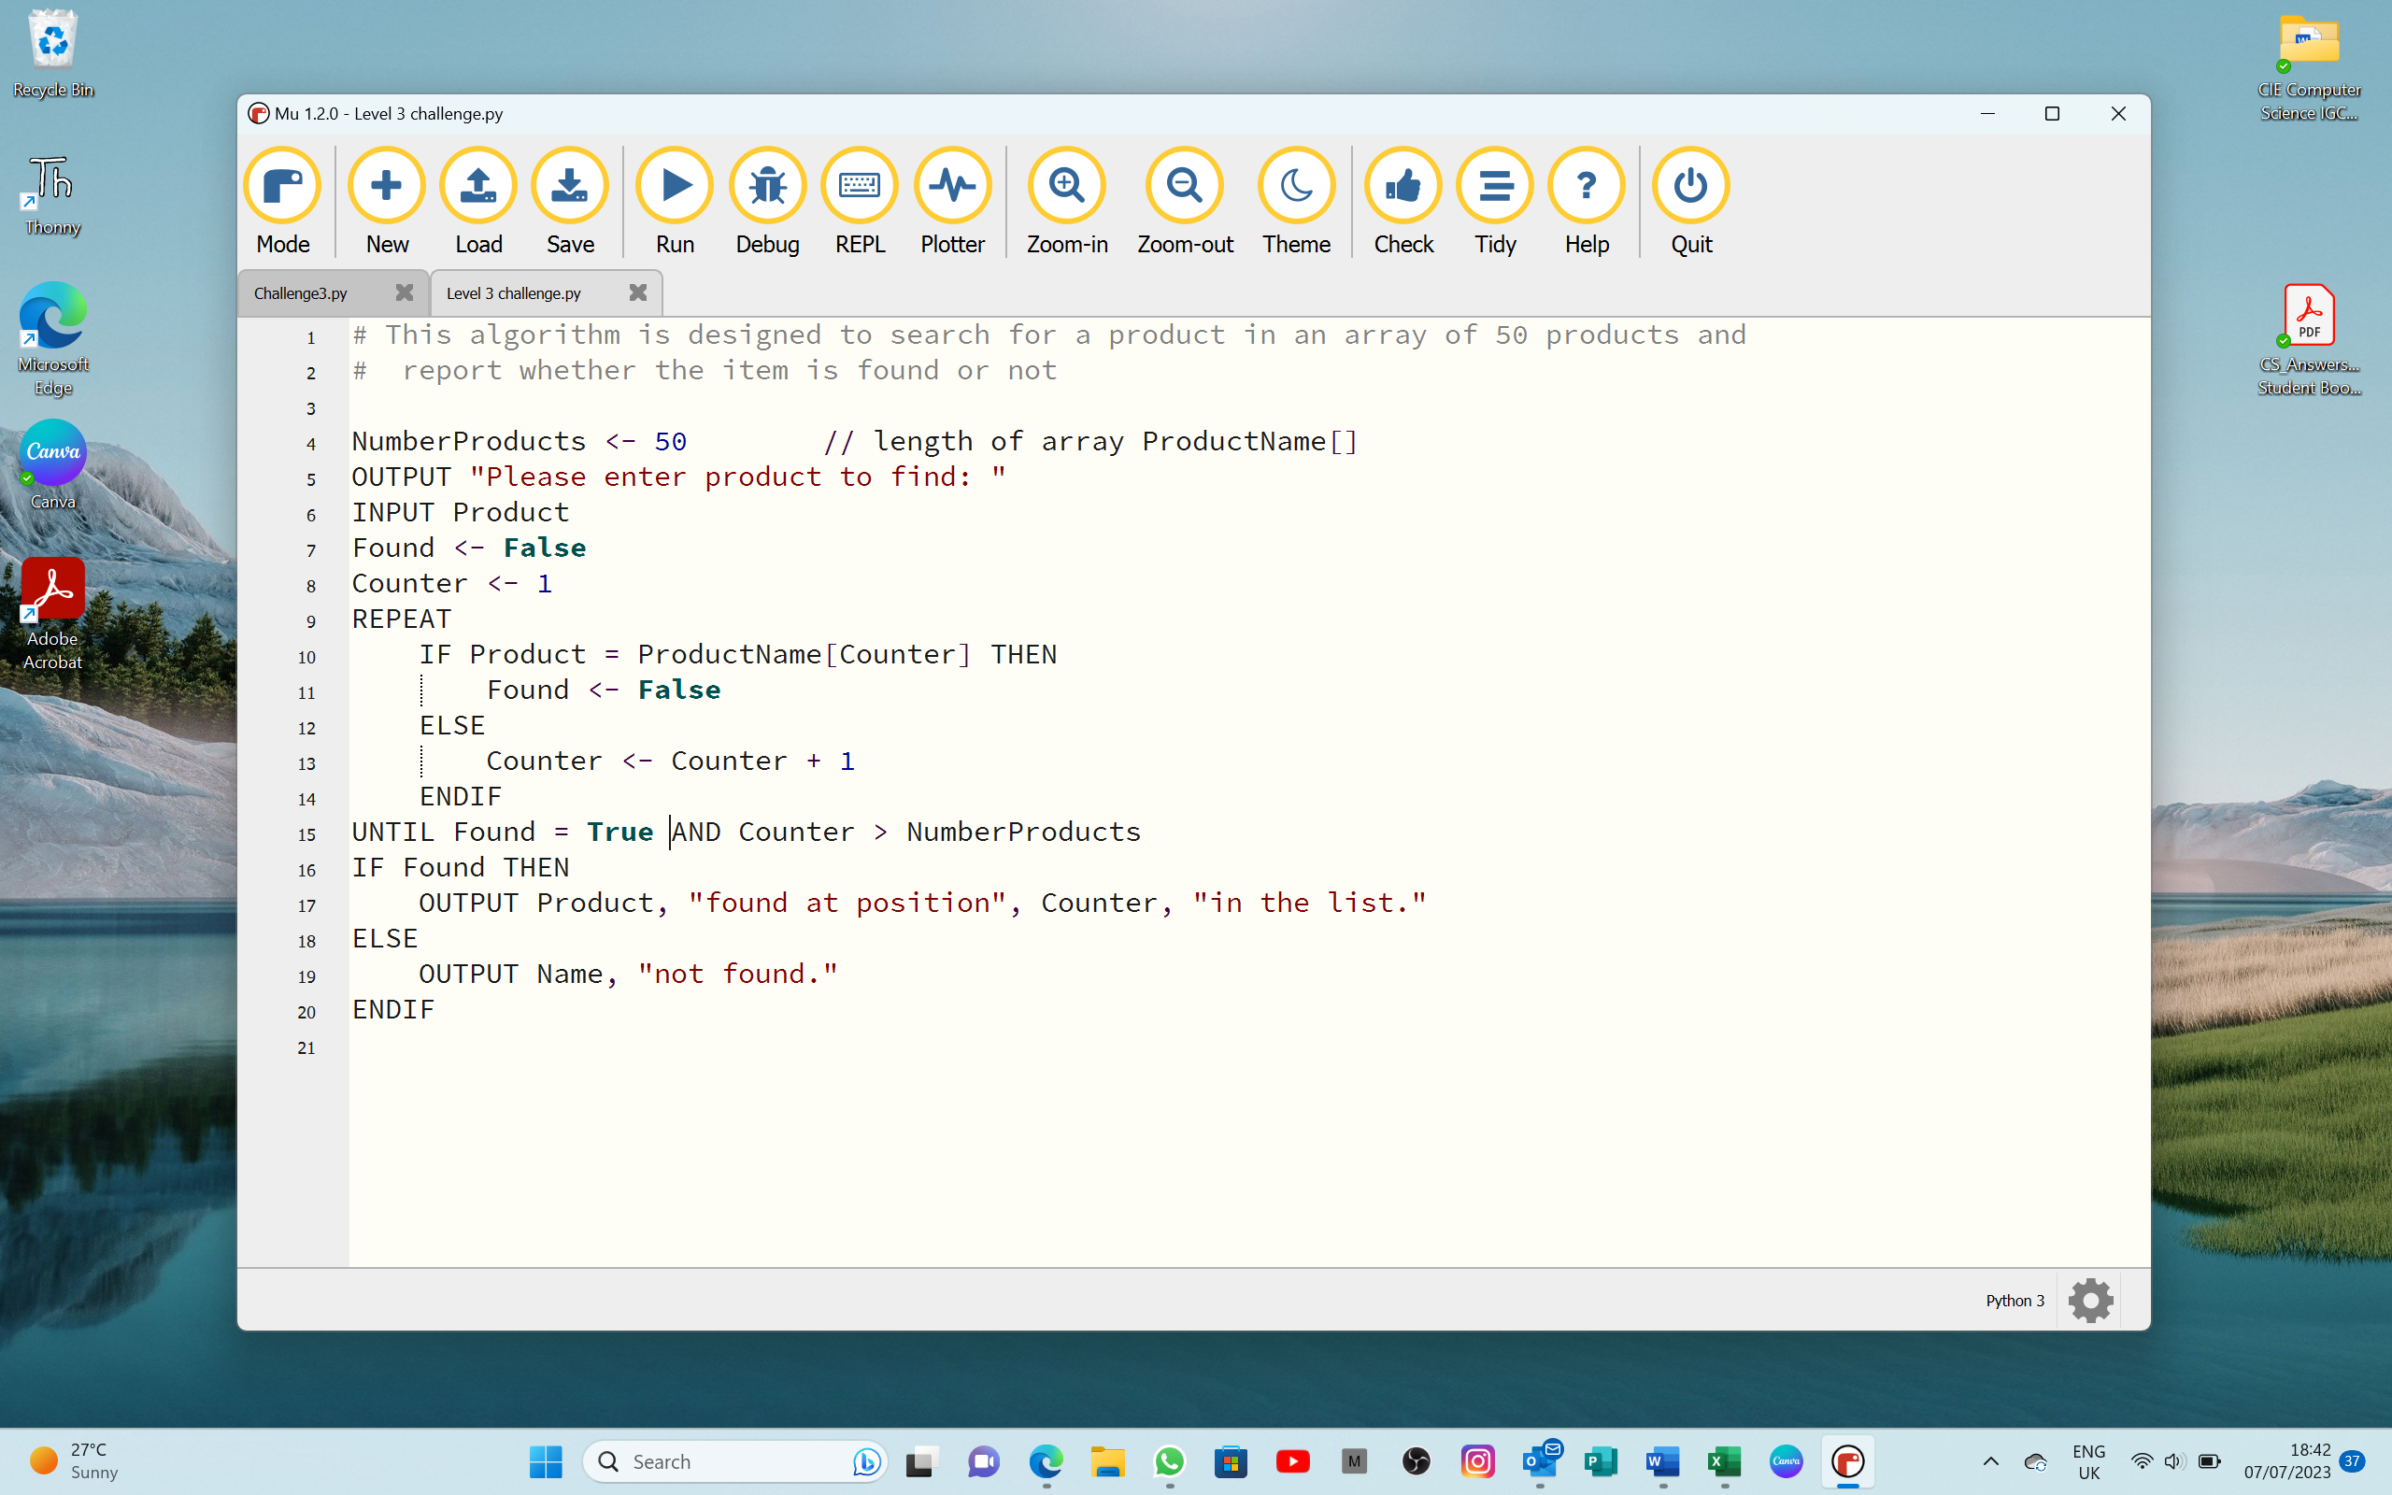

|  |
| --- |
| Error 1: |
| Correction: |
|  |
| Error 2: |
| Correction: |
|  |
| Error 3: |
| Correction: |
|  |
| Error 4: |
| Correction: |
|  |
| [4] |